## Curtin University – Department of Computing

## **Assignment Cover Sheet / Declaration of Originality**

## Complete this form if/as directed by your unit coordinator, lecturer or the assignment specification.

| Last name: | Bevacqua | Student ID: | 20162896 | |
| --- | --- | --- | --- | --- |
| Other name(s): | Austin | | | |
| Unit name: | Capstone Computing Project 1 | Unit ID: | ISAD3000 | |
| Lecturer / unit coordinator: | Senjian An | Tutor: |  | |
| Date of submission: | 03/06/2022 | Which assignment? | Final Milestone | (Leave blank if the unit has only one assignment.) |

## I declare that:

## · The above information is complete and accurate.

## · The work I am submitting is *entirely my own*, except where clearly indicated otherwise and correctly referenced.

## · I have taken (and will continue to take) all reasonable steps to ensure my work is *not accessible* to any other students who may gain unfair advantage from it.

## · I have *not previously submitted* this work for any other unit, whether at Curtin University or elsewhere, or for prior attempts at this unit, except where clearly indicated otherwise.

## I understand that:

## · Plagiarism and collusion are dishonest, and unfair to all other students.

## · Detection of plagiarism and collusion may be done manually or by using tools (such as Turnitin).

## · If I plagiarise or collude, I risk failing the unit with a grade of ANN (“Result Annulled due to Academic Misconduct”), which will remain permanently on my academic record. I also risk termination from my course and other penalties.

## · Even with correct referencing, my submission will only be marked according to what I have done myself, specifically for this assessment. I cannot re-use the work of others, or my own previously submitted work, in order to fulfil the assessment requirements.

## · It is my responsibility to ensure that my submission is complete, correct and not corrupted.

| Signature: | AUSTIN BEVACQUA | Date ofsignature: | 03/06/2022 |
| --- | --- | --- | --- |

## 

*ISAD3000 Capstone Computing Project Final Individual Report*

***Austin Bevacqua***

***Group E8: Amristar Industry Project [Virtual Jukebox]***

Group Members:

Austin Bevacqua, Bradley van der Zwan, Dillon Vincent,   
Ryan Webster, Tanaka Chitete

# Contents

**Assignment Cover Sheet / Declaration of Originality** **2**

**Progress Tracking** **4**

**Summary** **21**

## 

## Progress Tracking

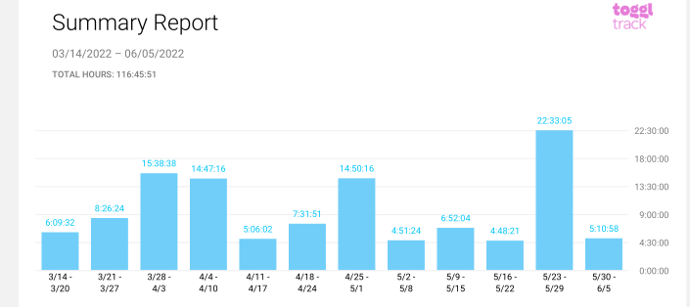

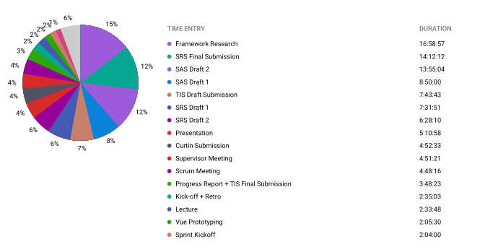

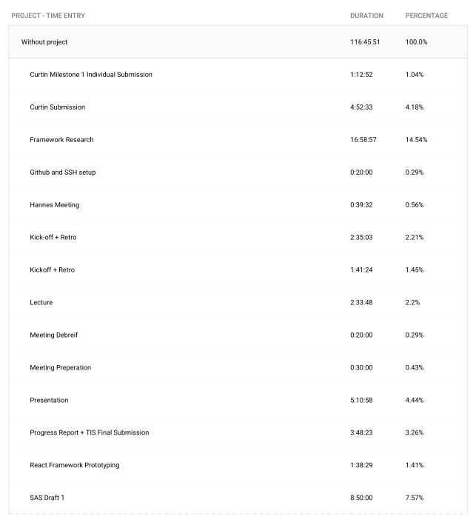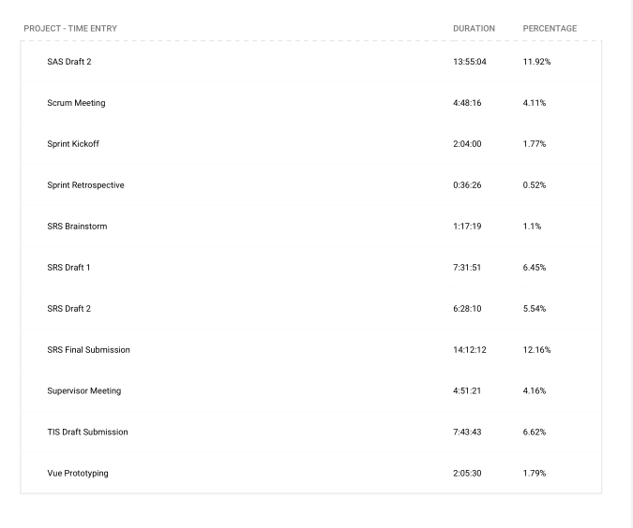

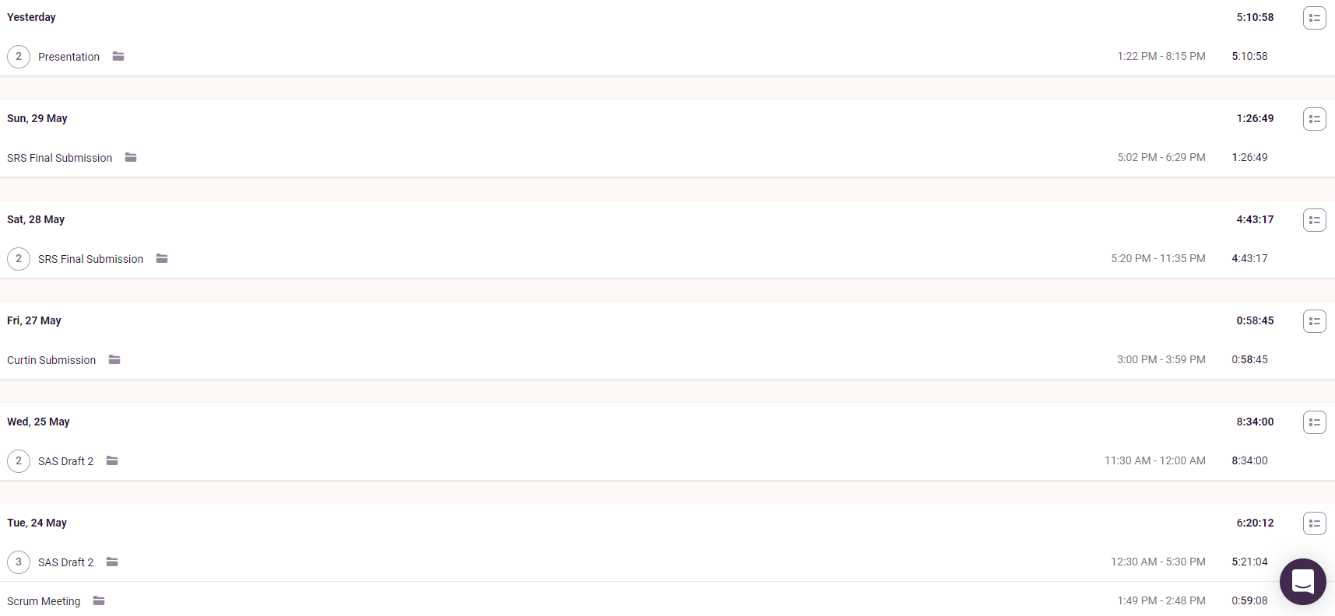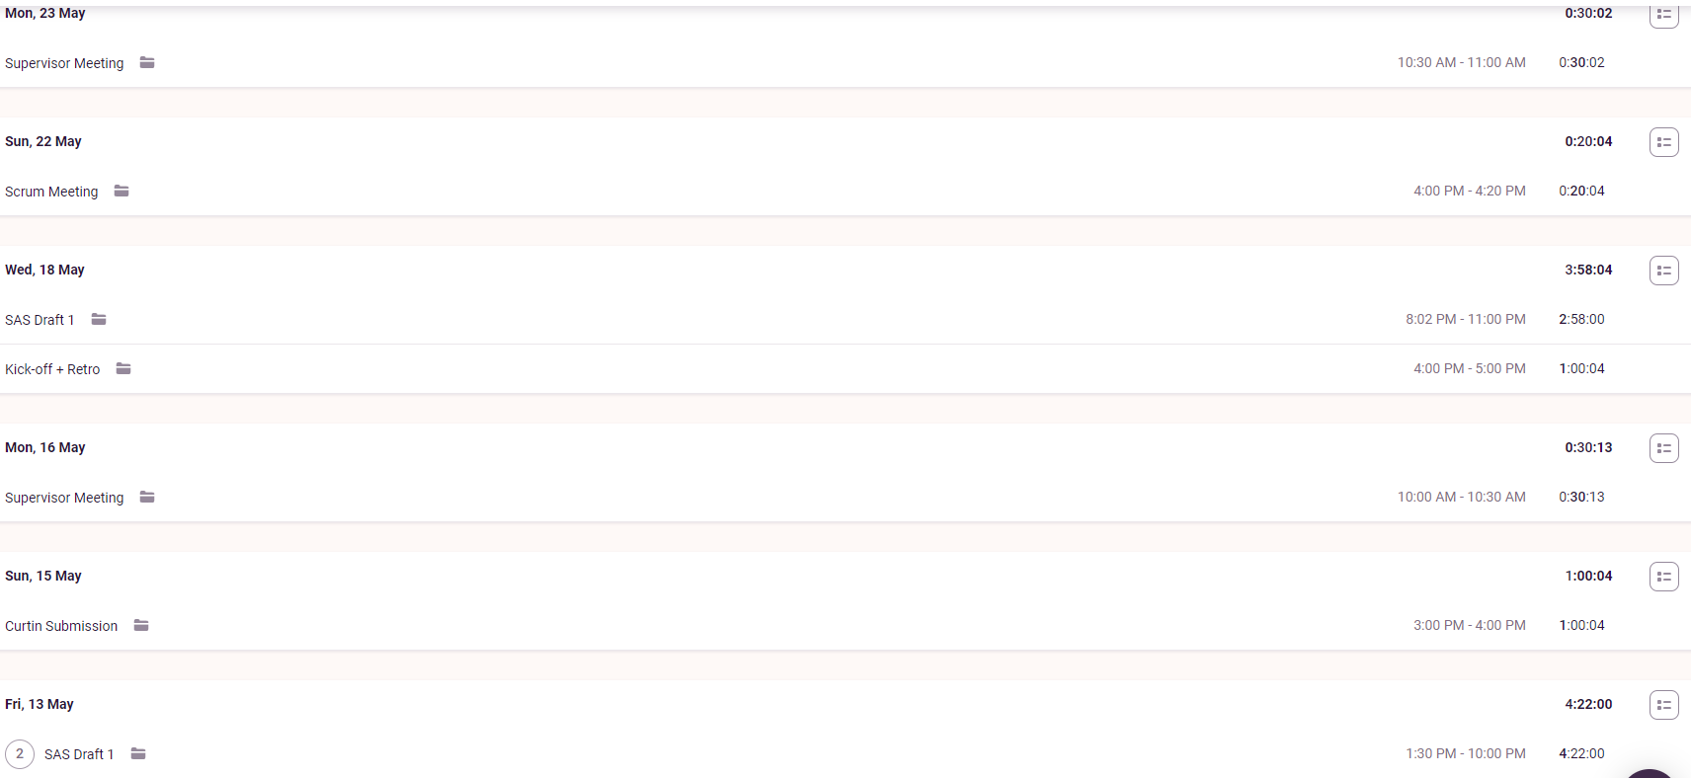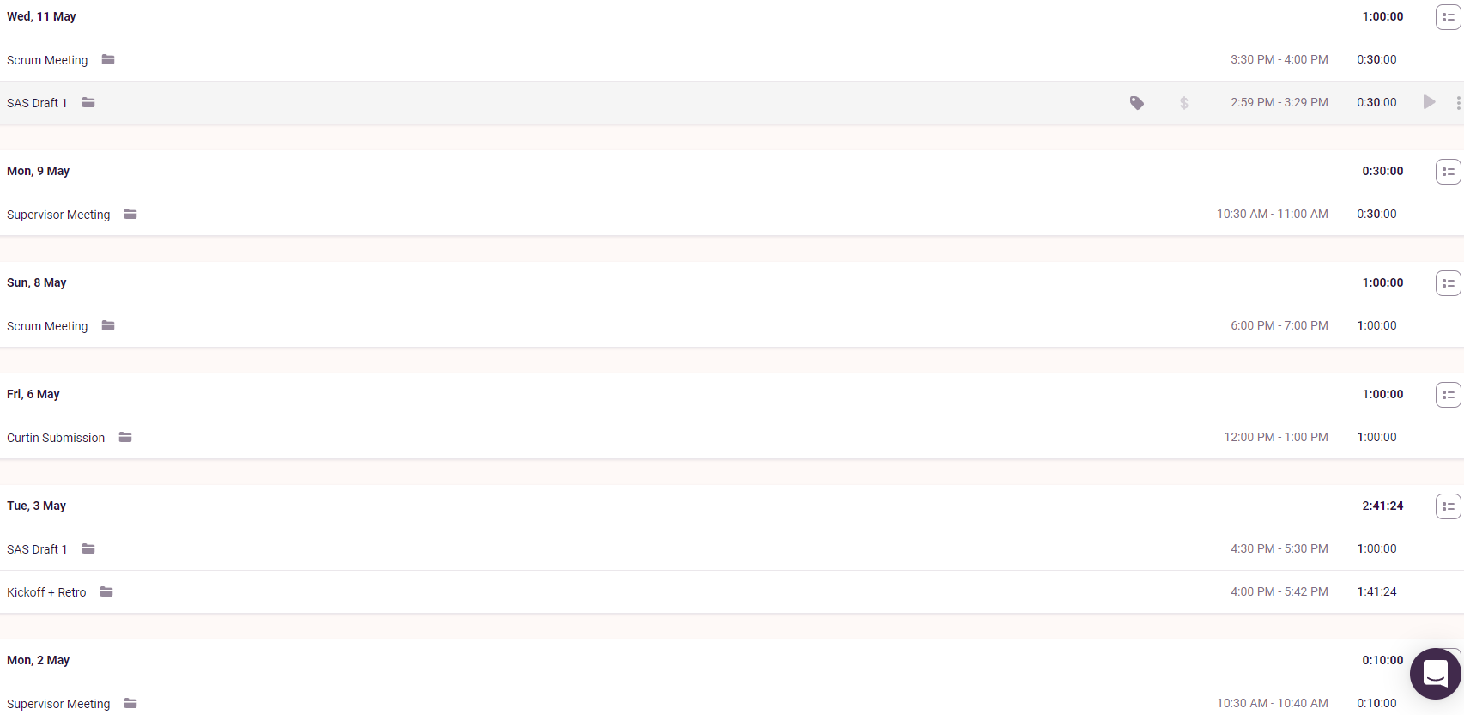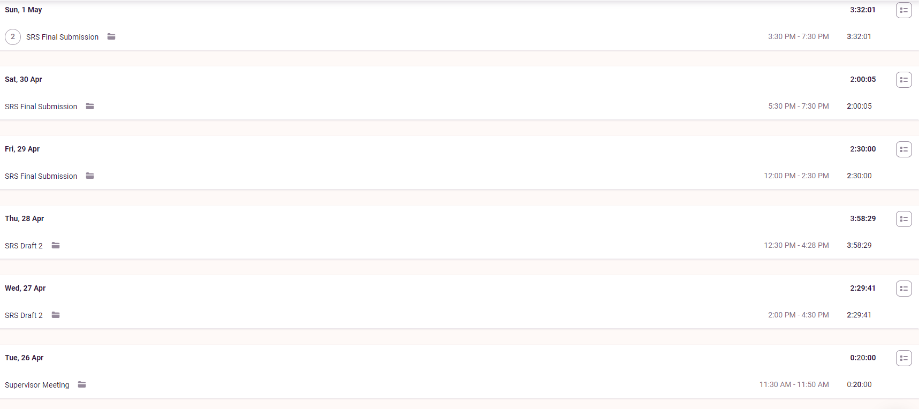

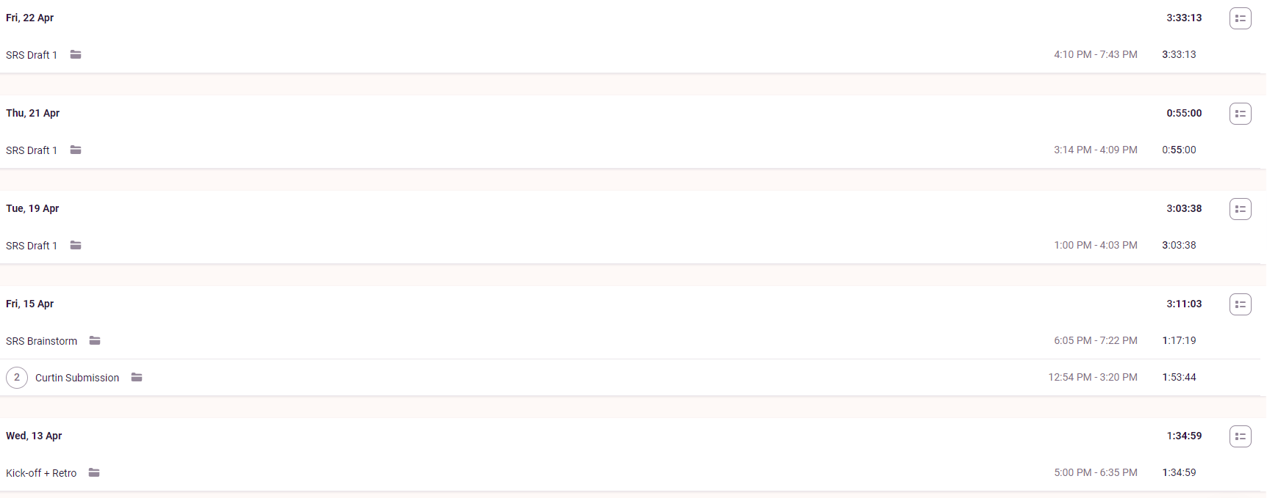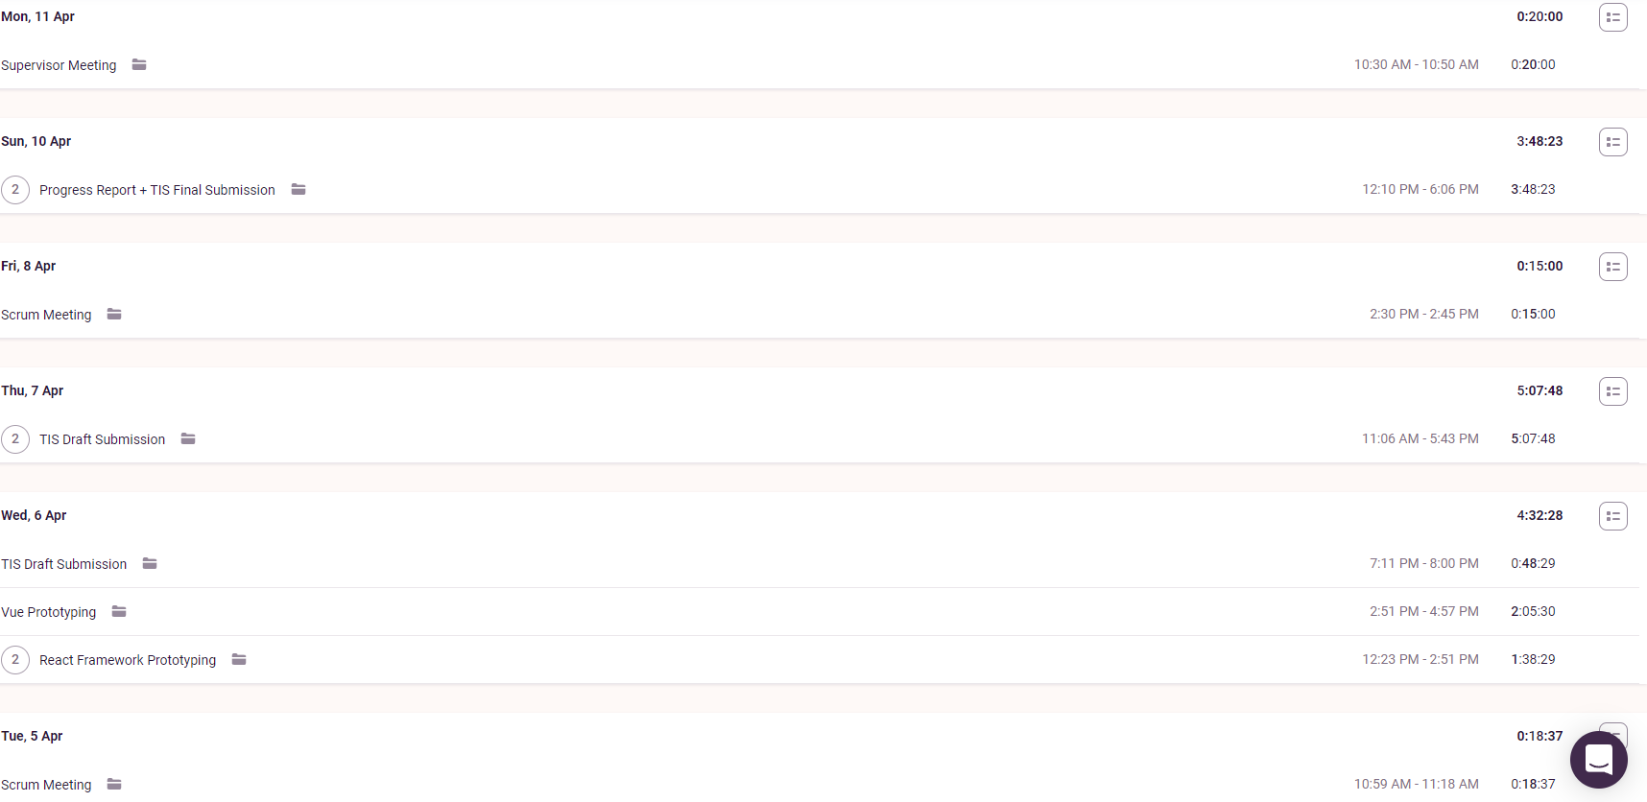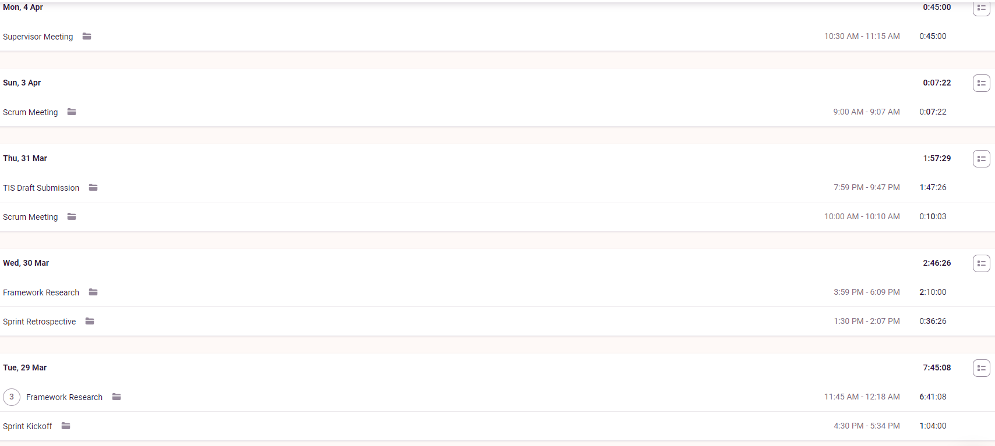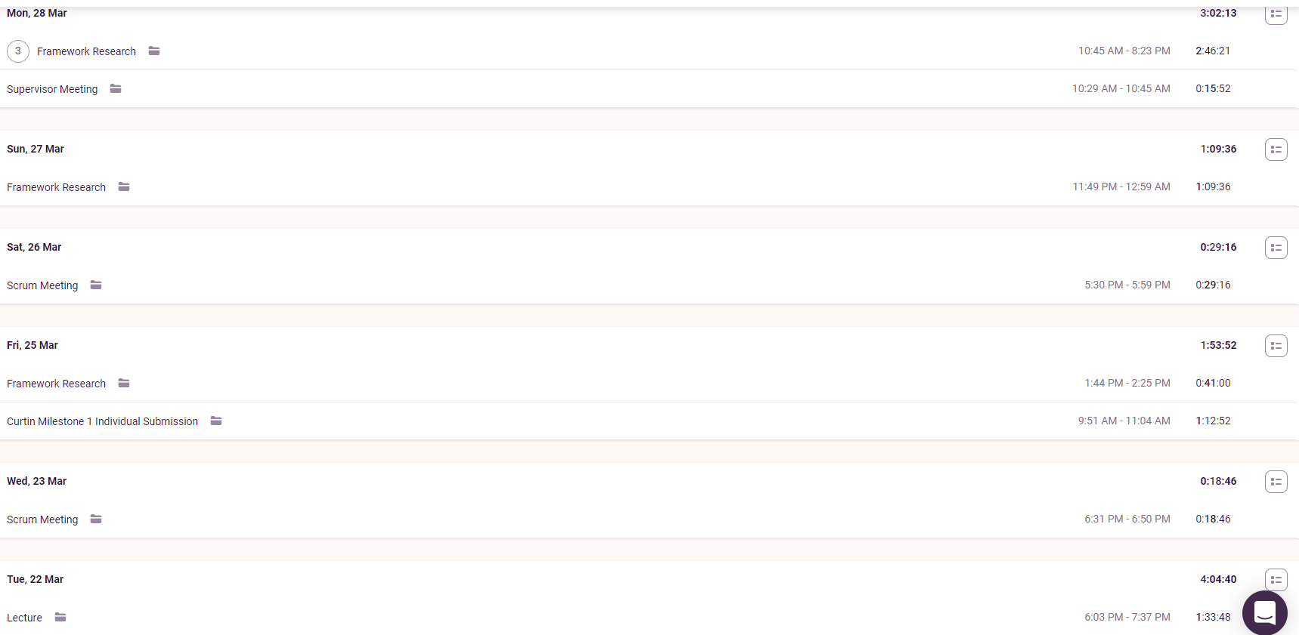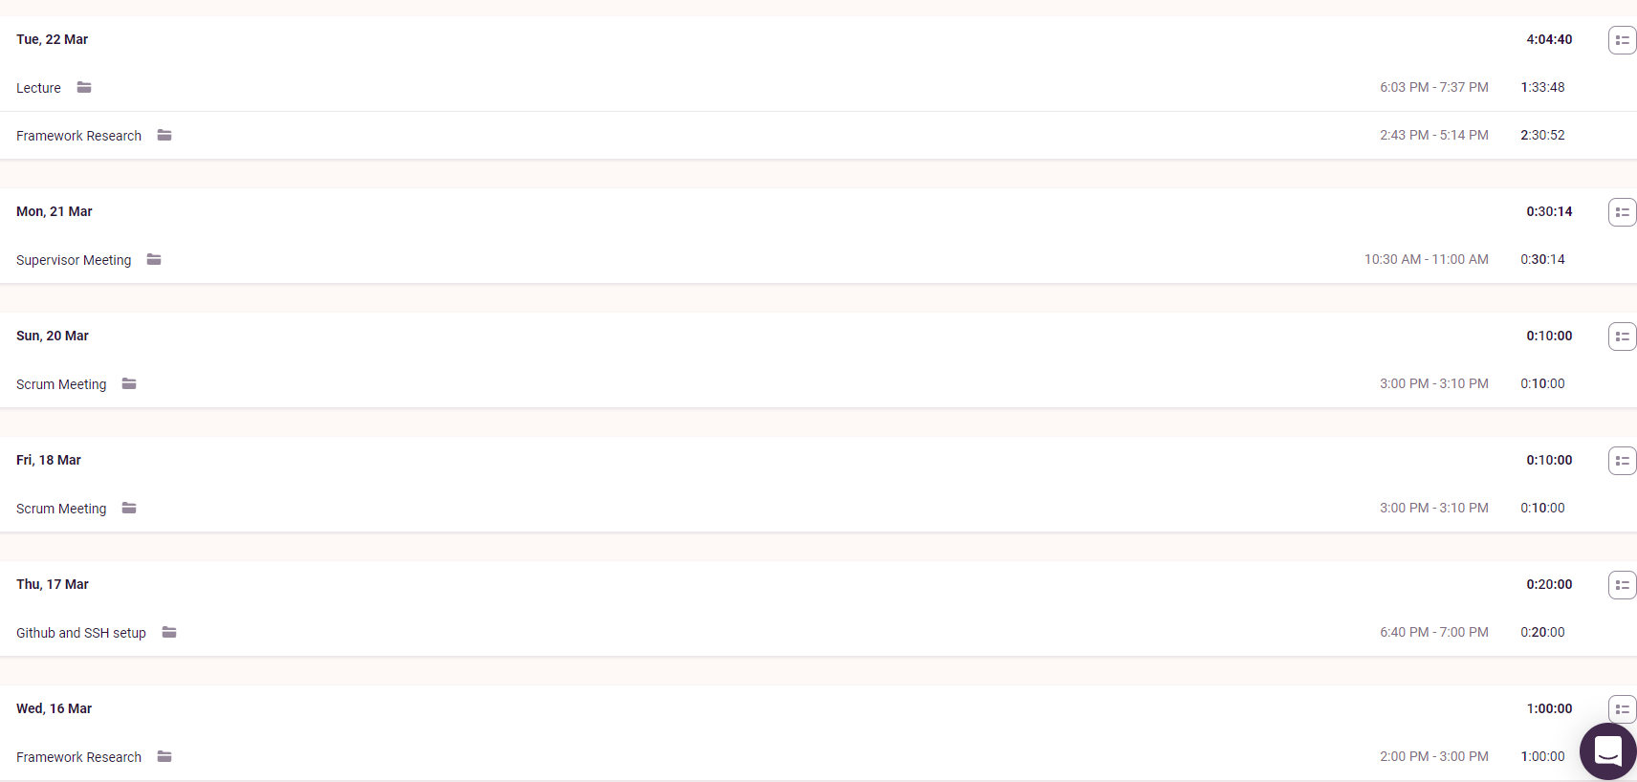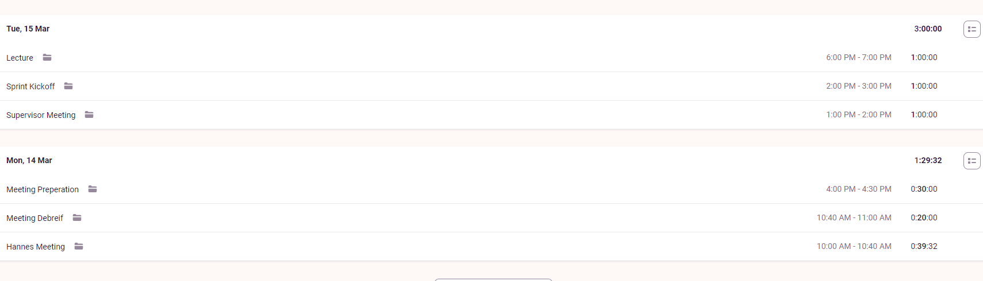

**Supervisor Meetings (Every Monday)**

Took part in supervisor meetings with Amristar. Discussed was the ongoing progress of the current deliverable .

Minutes taken by Bradley

[Supervisor Meetings](https://drive.google.com/drive/folders/1rKsgHWpck5Wpd935lpXTCyADSaPFoQgS?usp=sharing)

**Sprint Kickoff (5 Times)**

Sprint kickoffs were run and organised by myself. As our sprints are two weeks long, we discussed what we would be doing the next two weeks, and put these goals into tickets. We then did story point allocation, and assigned these tickets to a person.

Minutes for these meetings were written down by Bradley, who has included these documents in the group report.

[Team Meetings](https://drive.google.com/drive/folders/1OImhOwUw_PIgKJ7r6JA-oma24w2zfaJa?usp=sharing)

**Sprint Retrospective (5 Times)**

Sprint retrospectives were run and organised by myself. As our sprints are three weeks long, we reflected on how the last 2 weeks had gone, and came up with action items to improve on the next sprint. Retrospective meetings were run by having group members write down what they thought went well, and what could be improved on for the sprint. Every group member was then given 3 votes, and we discussed the highest voted cards.

Minutes for these meetings were written down by Bradley, who has included these documents in the group report.

[Team Meetings](https://drive.google.com/drive/folders/1OImhOwUw_PIgKJ7r6JA-oma24w2zfaJa?usp=sharing)

**Scrum Meetings (Around 3 per sprint)**

Scrum meetings were run and organised by myself. Each meeting consists of the following questions:

* What have you been doing?
* What are you currently doing?
* What will you be doing?
* Are you having problems with anything?

Answers to these questions were written down by Bradley, who has included these documents in this report. We also used the scrum meeting times to discuss submissions, meetings with supervisors and when the next meeting would take place.

[Team Meetings](https://drive.google.com/drive/folders/1OImhOwUw_PIgKJ7r6JA-oma24w2zfaJa?usp=sharing)

**Lectures (15 March, 22 March)**

I watched both Aneesh’s Scrum lecture on the 15th and Hannes’ SRS workshop on the 22nd. Bradley and myself used the time after the workshop to talk about the Curtin submissions, scrum progress, and exchange research on investigated technologies.

**Technology Investigation (15th March - 29th March)**

After the sprint kickoff, I was assigned to do research into frontend and backend frameworks for the technology investigation. All my work was done on the cloud on Google slides, so all times I edited the document are visible.

Frontend Technology investigation: [Tech Investigation](https://docs.google.com/presentation/d/1qGjtVOsfglGwDRRtJJ-COLKPchtvUG0RCZ7N68MP920/edit?usp=sharing)

Backend Technology Investigation: [Backend Investigation](https://docs.google.com/presentation/d/1V9lEM1aUGhMTJdL-NAEP3zJnzHv1uPppNCGQk29qTRM/edit?usp=sharing)

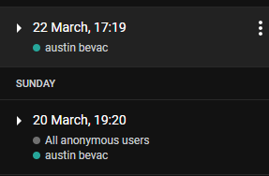

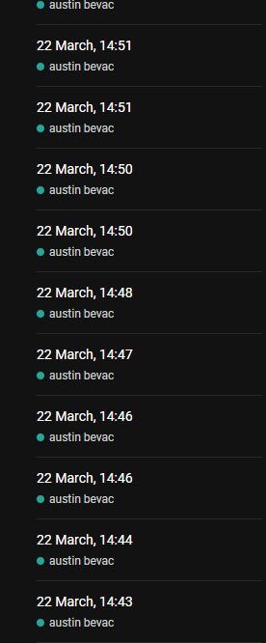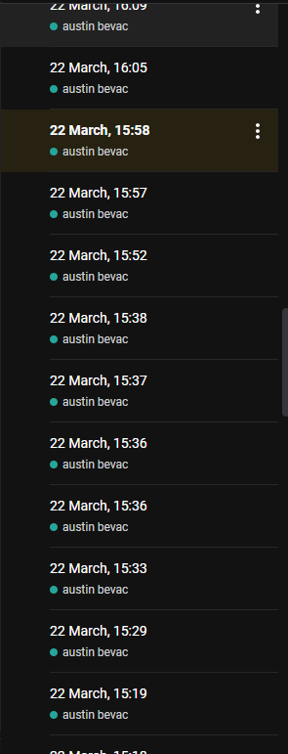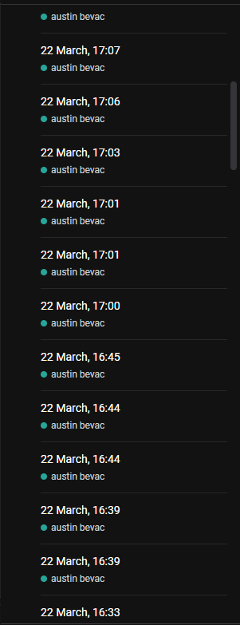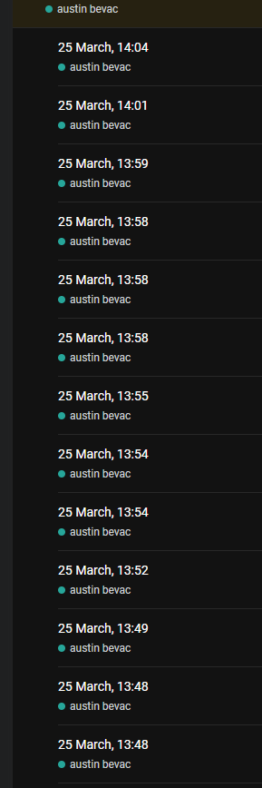

**Framework Research (27th March - 30th March)**

I continued my work researching frontend and backend frameworks. A significant amount of time was spent this sprint to create a detailed comparison between the top candidates for frontend and backend frameworks, to ensure the submitted TIS would be high quality and the chosen technology stack would be as suitable as possible.

All my work was done on the cloud on Google slides, so all times I edited the document are visible.

Frontend Technology investigation: [Tech Investigation](https://docs.google.com/presentation/d/1qGjtVOsfglGwDRRtJJ-COLKPchtvUG0RCZ7N68MP920/edit?usp=sharing)

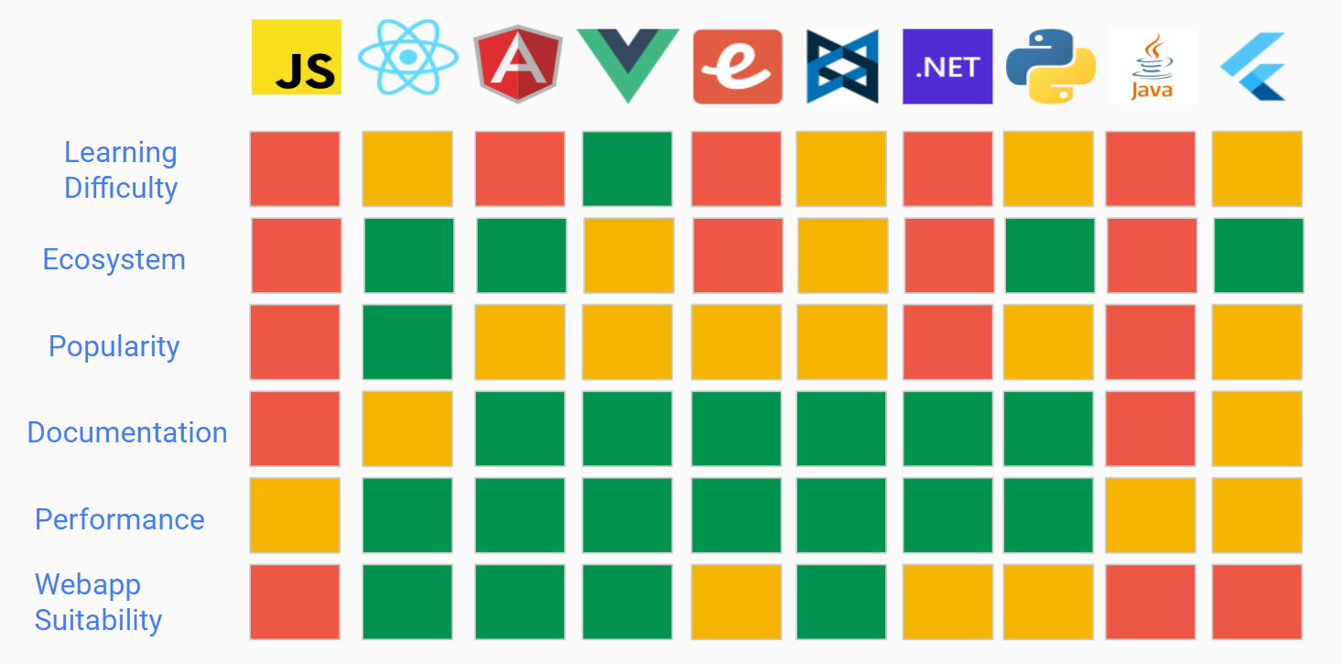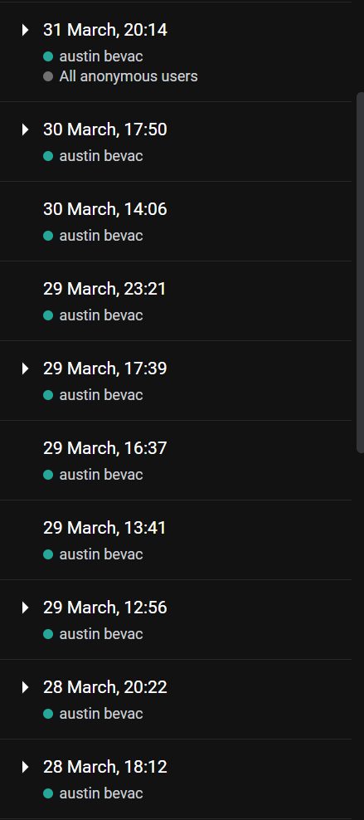

Backend Technology Investigation: [Backend Investigation](https://docs.google.com/presentation/d/1V9lEM1aUGhMTJdL-NAEP3zJnzHv1uPppNCGQk29qTRM/edit?usp=sharing)

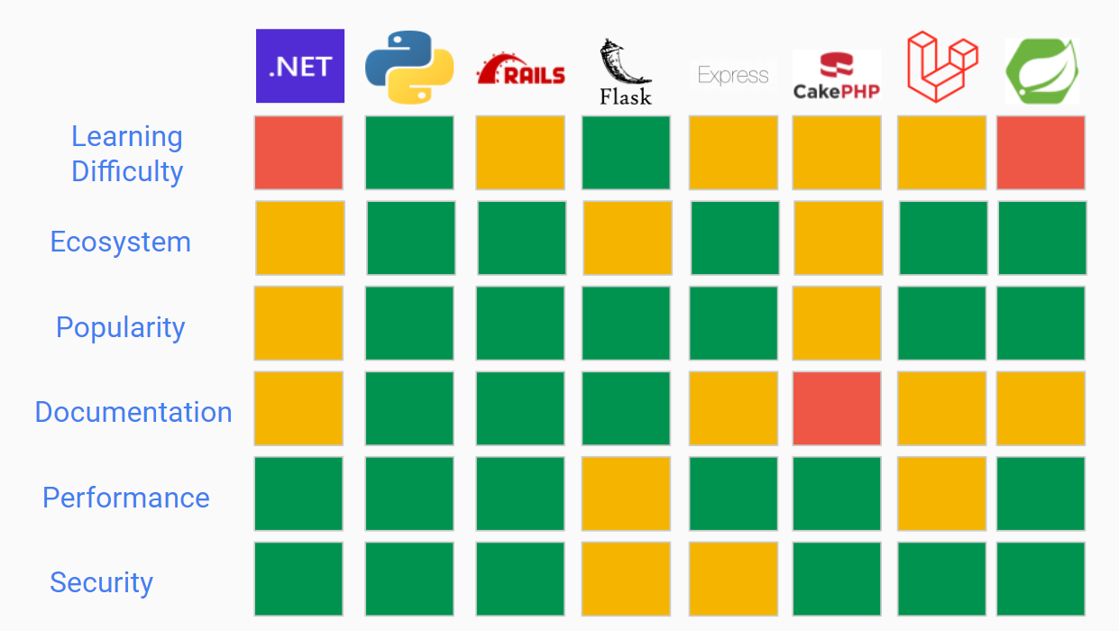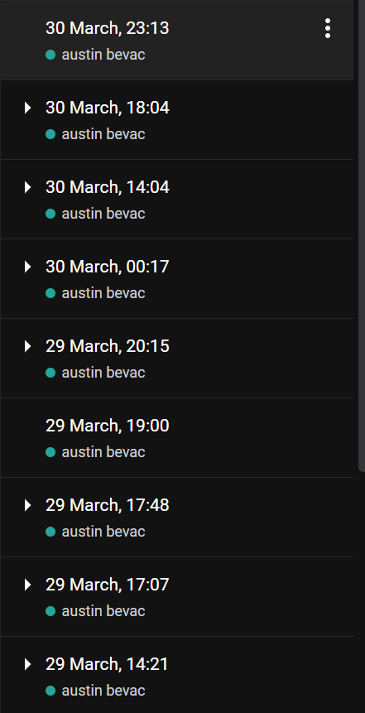

**TIS Drafts + Final Submission (31st March - 10th April)**

The main deliverable of this milestone was the submission of the TIS to Amristar. As a group, we created two drafts, which we then sent to Amristar for feedback, and a final submission. I was responsible for writing the frontend and backend sections of these documents, as well as helping out with document formatting, grammar and consistency.

The below link contains all 3 drafts, which showcase the edit history of all three documents.

[TIS Submissions](https://drive.google.com/drive/folders/1HRwxF2hvAp7NuhtgTB_6Otp_VpU6UqQa)

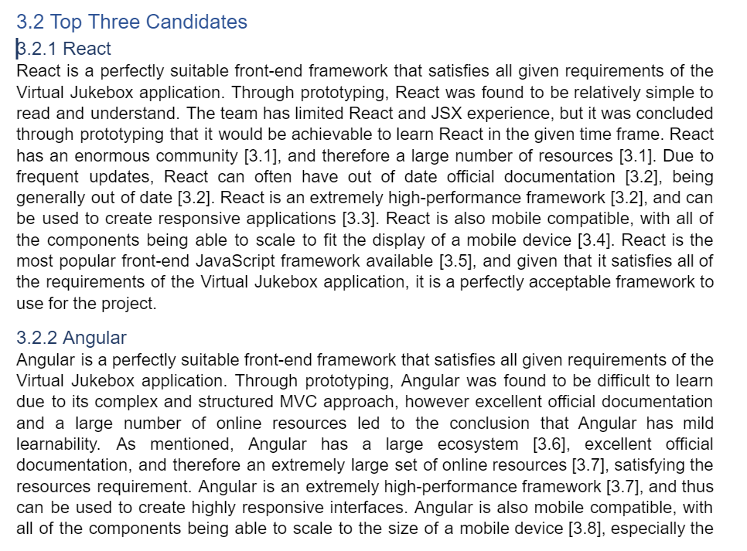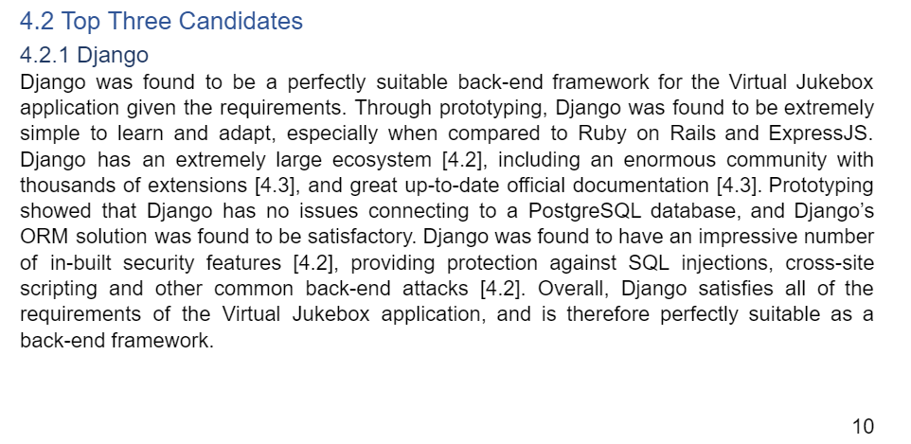

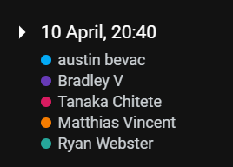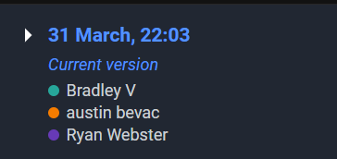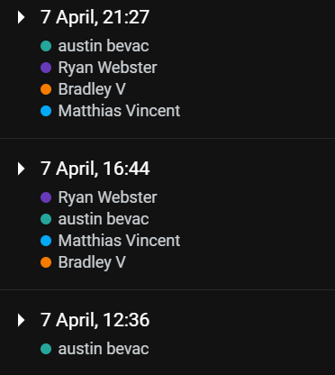

**Vue + React Prototyping (6th April)**

As part of our TIS, Amristar instructed us to conduct basic prototyping so that we could ensure all the elements of our technology stack would be able to communicate with each other. We decided to prototype our top three frontend frameworks, and see which would be the best fit for what we needed. I was in charge of Vue and React prototyping, while Dillon conducted Angular prototyping.

React prototype:

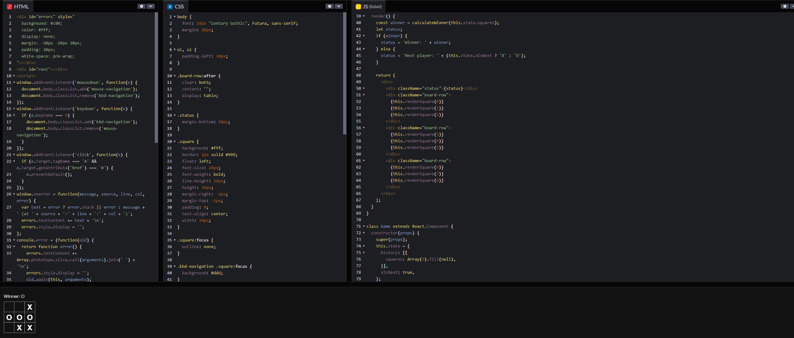

Vue prototype:

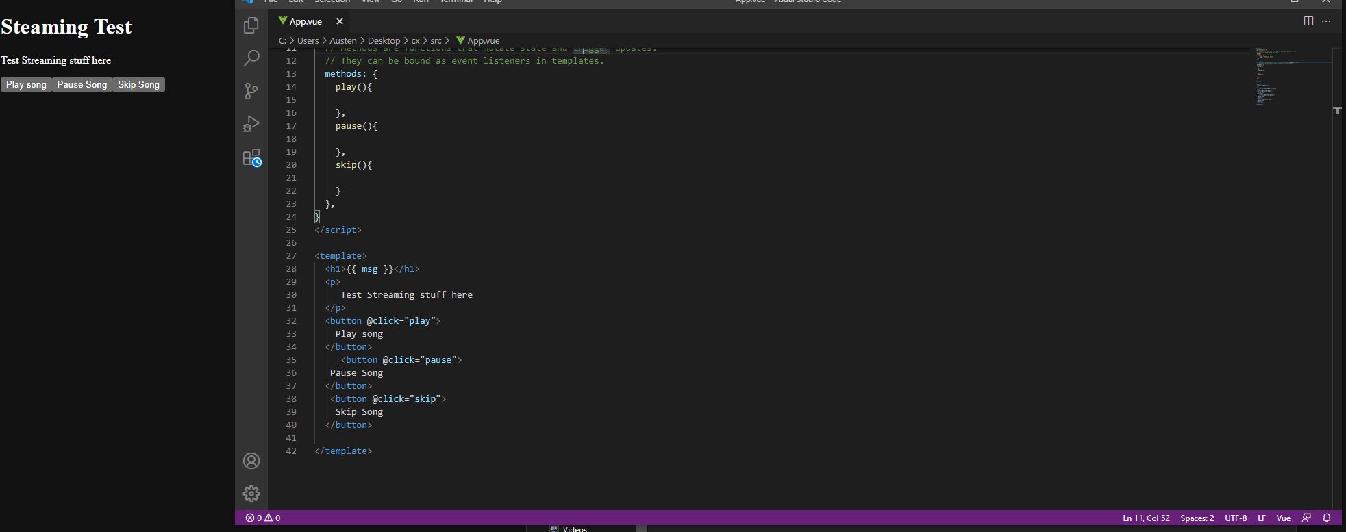

**SRS Drafts 1 + 2 (19th - 28th April)**

Progress made on the SRS deliverable. This includes formatting, functional requirements, nonfunctional requirements, defining actors, ect…

I wrote the functional requirements, and formatted the functional and nonfunctional requirements based on the Amristar feedback.

Edit history for the document, including both drafts, can be seen here.

[Software_Requirements_Specification_(v2.0).docx](https://docs.google.com/document/d/1CQ3ZUu5cgSV7MMw2JtgrXopPUMZS4N3i/edit)

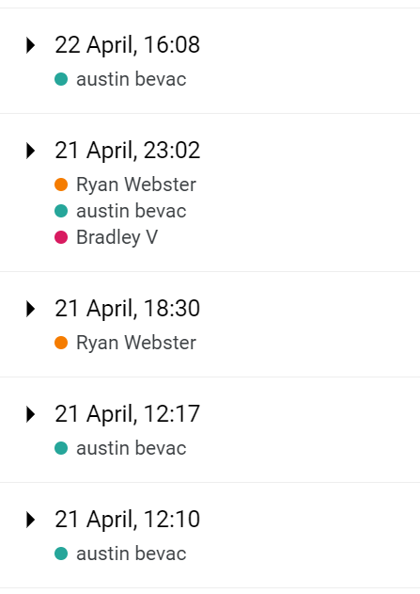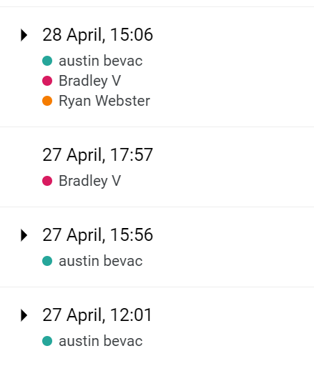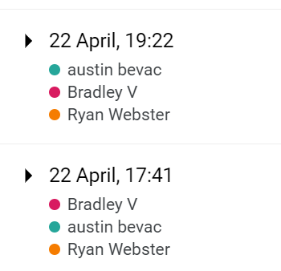

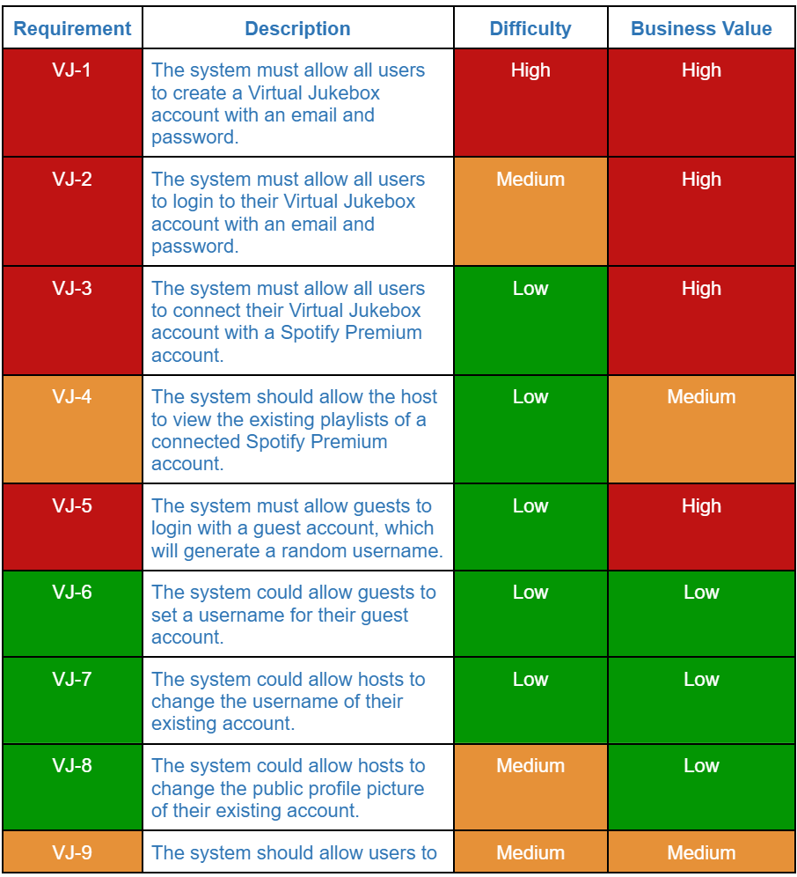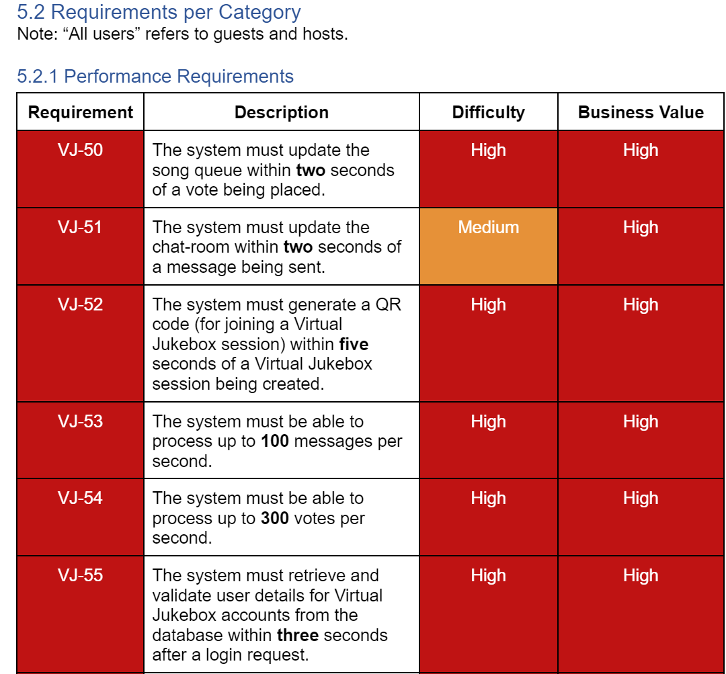

**Final SRS Submission + Project Plan (29th April - 1st May)**

Final iteration of the SRS, where the feedback from draft 2 was implemented.

The final submission also included work on the project plan, where I estimated story points for all ~200 tasks, and allocated people towards the tasks.

Included in “SRS Final Submission” on Toggl.

Submissions for the SRS Drafts can be seen at this link. Note edit history is not available as these are copies of the original document. To view edit history, view the document link above.

[SRS Submissions](https://drive.google.com/drive/folders/18p0U6w9yyfh61fs7rk_411_MaoRMnZaE)

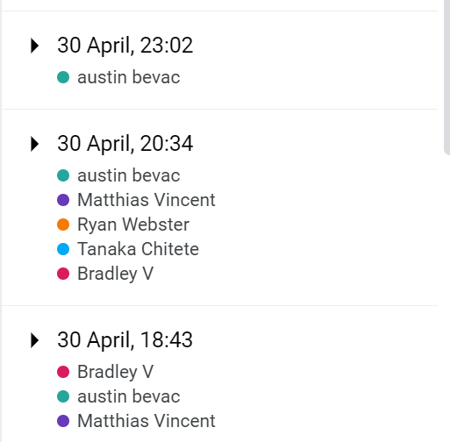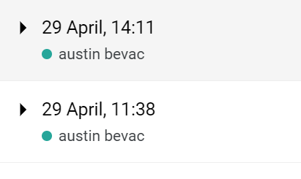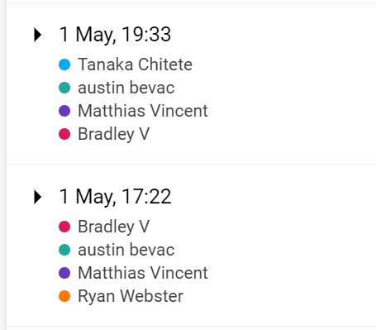

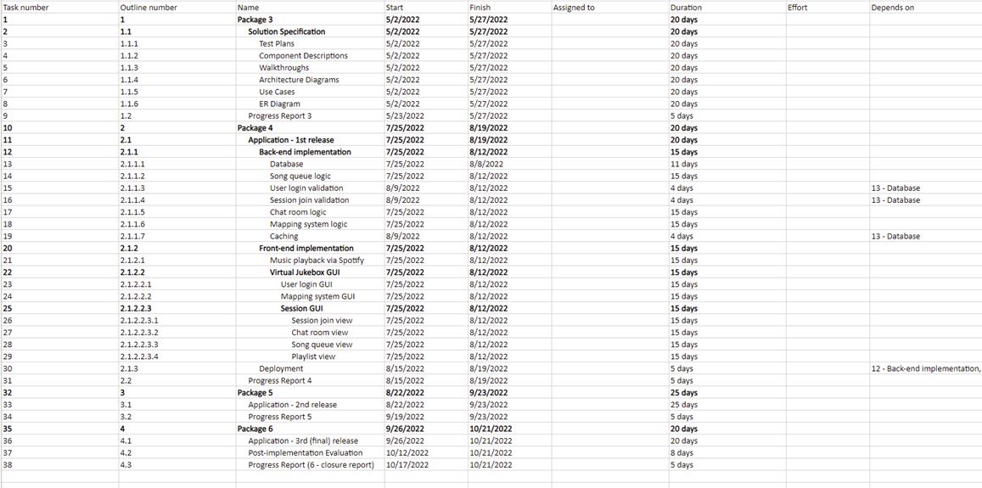

**SAS Drafts 1 + 2 (3rd May - 25th May)**

Progress made on the SAS deliverable.

I was responsible for the following sections:

* Business Model - Organisational Context
* Business Model - Current Situation
* Business Model - Solution Definition
* Business Model - Actors
* Business Model - Interactions of Actors
* Business Model - Use Cases

Edit history for the document, including both drafts, can be seen here.

[Software_Architecture_Specification_(v0.1)](https://docs.google.com/document/d/1mcSgu2c_w5R5AETjS3u6trfVxSqU1SJos2QDoY-dQ5o/edit)

[Software_Architecture_Specification_(v1.0)](https://docs.google.com/document/d/1SyL3lQxn-WuiYlmj1VGFqQ0DLbQE_YICIXJrieaQPP4/edit#heading=h.hfkoqxk1unb2)

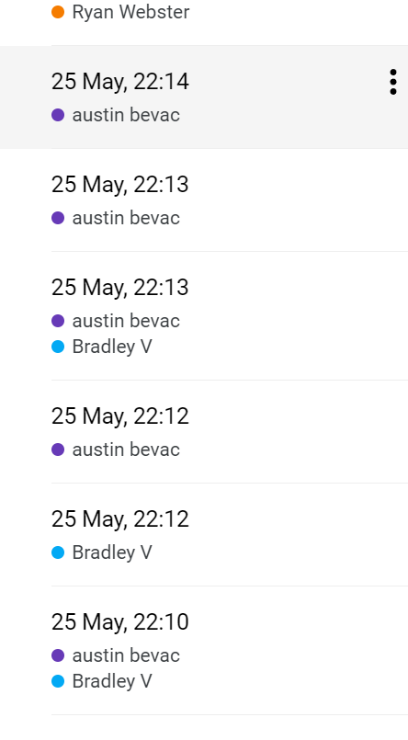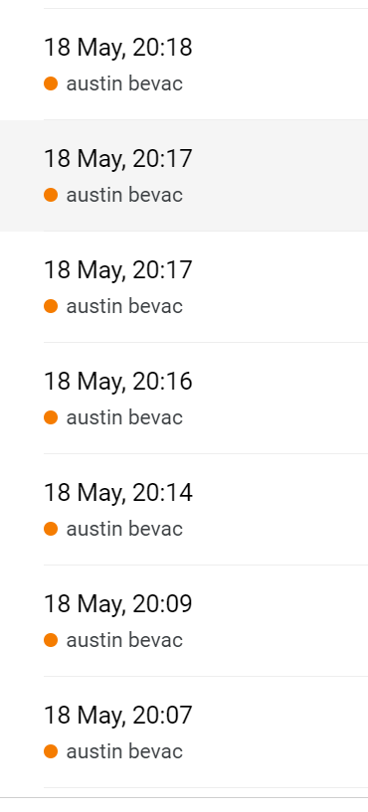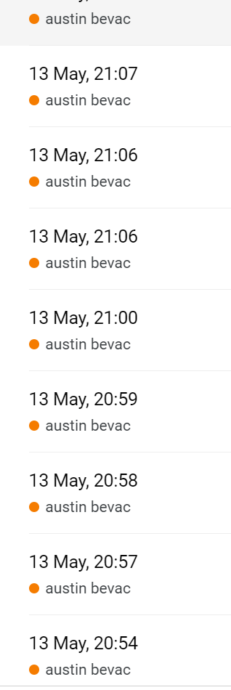

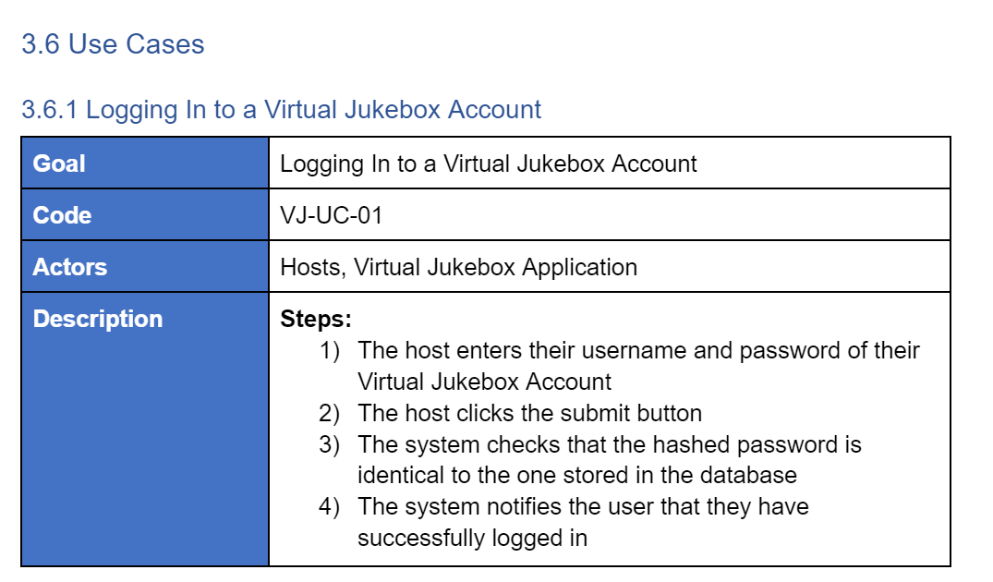

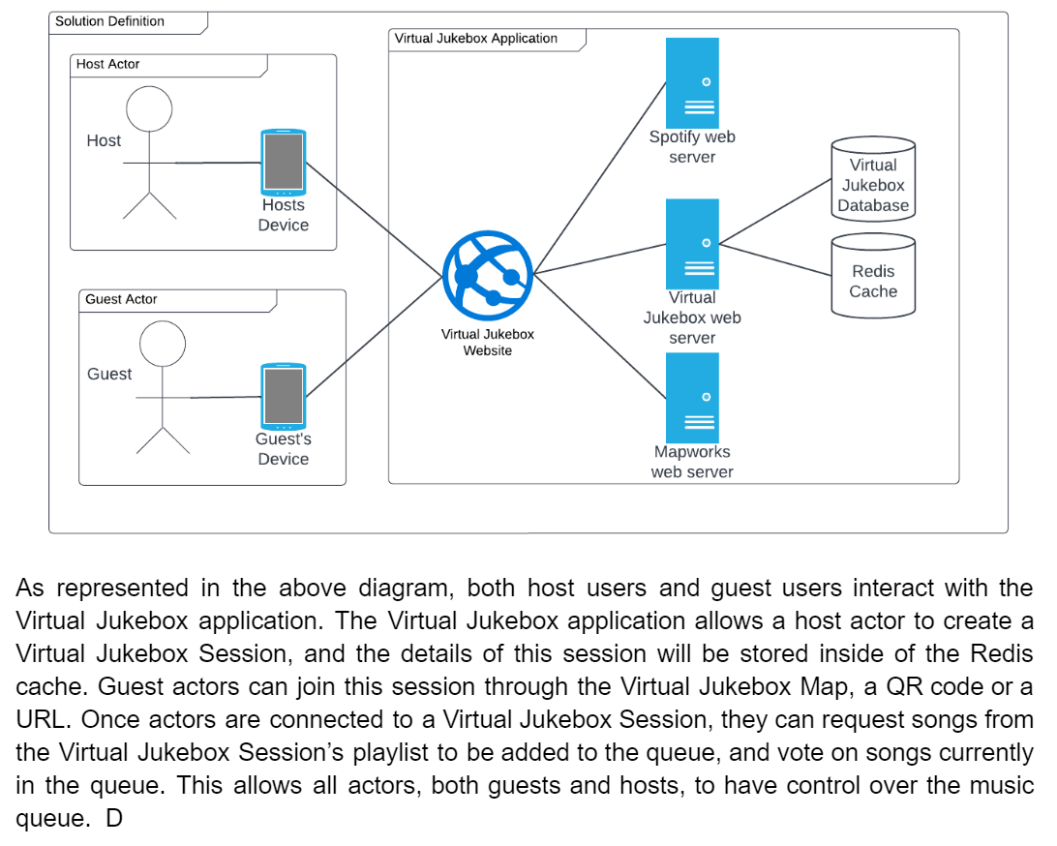

**SAS Final Submission (28th May - 29th May)**

Final submission for the SAS deliverable. Refined work based on feedback.

[Software_Architecture_Specification_(v1.0)](https://docs.google.com/document/d/1SyL3lQxn-WuiYlmj1VGFqQ0DLbQE_YICIXJrieaQPP4/edit)

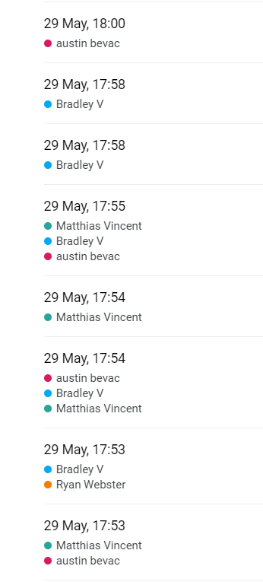

**Presentation (3th April - 6th April)**Created slides, rehearsed and presented at the Amristar offices a summary of the work done this semester.

<https://docs.google.com/presentation/d/12jQCCuUqEFKbZ5lFL9o0DT7xCazLcqRfKSKTFOwiU2k/edit>

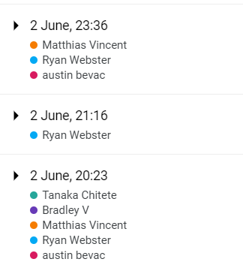

**Curtin Milestone Submissions (5 in total)**

This document + group report, where I added my work over the previous period. 5 completed throughout the semester.

## Summary

Overall, we are extremely pleased with the progress and deliverables submitted in semester one. We feel that we have set ourselves up for success by producing high-quality documents which will be referred to during the programming phase. The group now has a better understanding of the Agile process, and are confident in using Jira. As a group we now know each other’s strengths and weaknesses, and will use this to our advantage going forward.